Flow of Data

12/08/2024

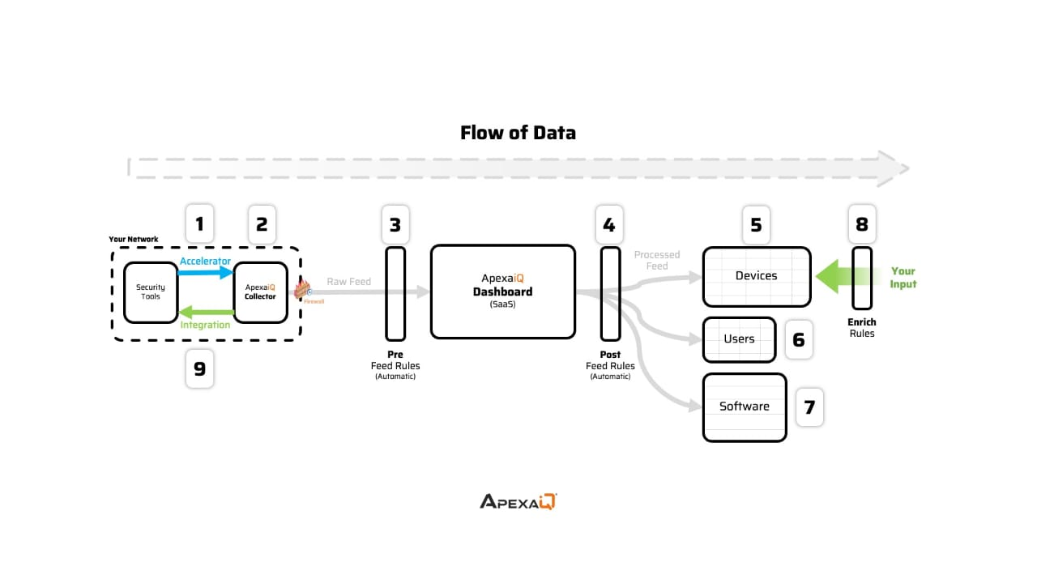

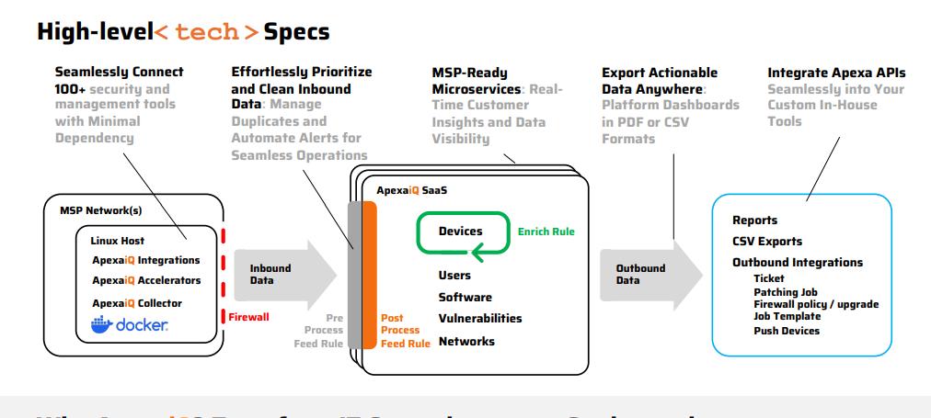

**1. Seamlessly Connect (Left Section – MSP Network)**

* **Goal:** Bring in data from different sources into ApexaiQ with minimal effort.
* **Components:**
  + **Linux Host** – The base system where ApexaiQ collectors can run.
  + **ApexaiQ Integrations** – Collectors that link to various security & management tools.
  + **ApexaiQ Accelerators** – Speed up the data collection and processing.
  + **ApexaiQ Collector** – Gathers raw asset, vulnerability, and system data.
  + **Docker** – Used to containerize and run these tools efficiently.

**Process:**  
Data flows from the MSP’s tools → into the ApexaiQ Collector → passes through the **firewall** → sent as **Inbound Data** to the SaaS platform.

**2. Effortlessly Prioritize and Clean Inbound Data (Middle Left – Pre-Processing)**

* **Action:** Before data is fully processed, ApexaiQ:
  + **Removes duplicates**.
  + **Cleans data** for accuracy.
  + **Applies alerts** for priority cases.
* This ensures only relevant and structured data moves forward.

**3. ApexaiQ SaaS Core Processing (Middle – Enrich Rule)**

* **Post Process Feed Rule:** Data enters the main SaaS platform for deeper processing.
* **Enrichment:**
  + Adds context like **obsolescence**, **warranty info**, **vulnerability severity**, and **compliance data**.
* **Main Managed Items/Inventory:**
  + **Devices**
  + **Users**
  + **Software**
  + **Vulnerabilities**
  + **Networks**

This creates a **single source of truth** for asset intelligence.

**4. Export Actionable Data (Middle Right – Outbound Data)**

* Processed and enriched data can be **exported**:
  + **PDF Reports**
  + **CSV Files**
* Accessible through ApexaiQ dashboards for analysis or decision-making.

**5. Integrate ApexaiQ APIs (Right Section – Outbound Integrations)**

* **Reports** & **CSV Exports** can be integrated into your existing in-house tools.
* **Outbound Integrations** allow:
  + Creating tickets
  + Triggering patch jobs
  + Updating firewall policies or upgrades
  + Running job templates
  + Pushing device configurations

This enables **real-time actions** based on the insights gathered.

**In short:**

1. **Inbound:** Data from your network tools → Collected → Cleaned & Prioritized.
2. **Processing:** Enriched with risk, compliance, and lifecycle intelligence in ApexaiQ SaaS.
3. **Outbound:** Export or integrate with other tools for automated responses and reporting.